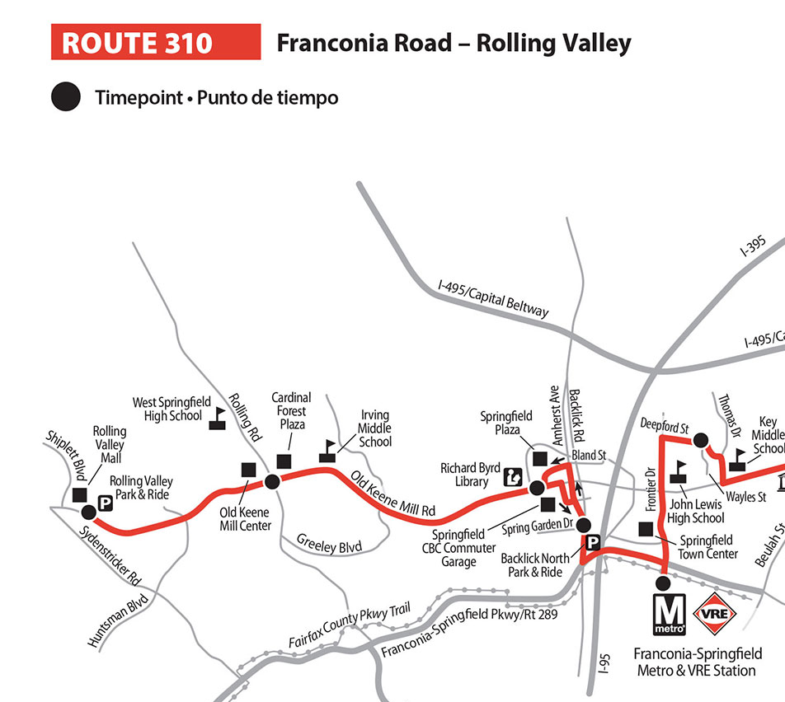
SPRINGFIELD COMMUNITY
- PARKING GARAGE -
BUS STOP LOCATION
AND SCHEDULE
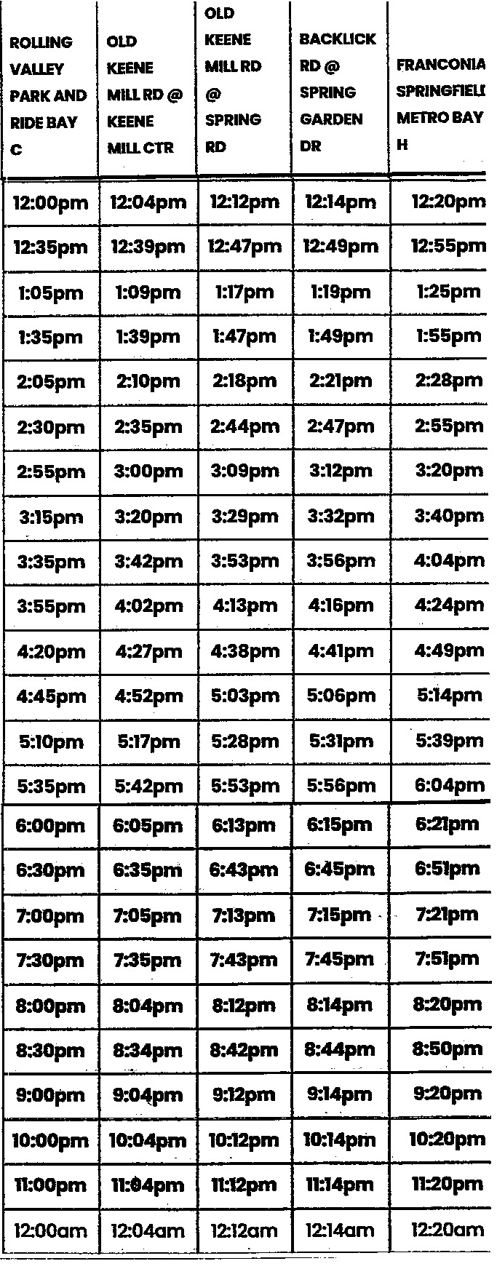
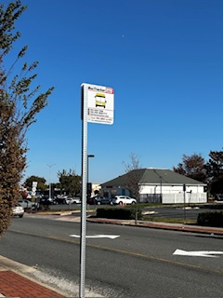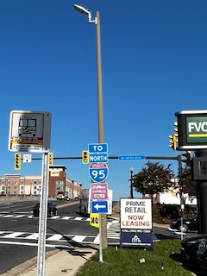
STOP ID 1226 – Text 1226 to 41411
Springfield Blvd and Amherst Ave
Across from American Legion
Fare $ 2.25
STOP ID 6903 – Text 6903 to 41411
Bland St and Old Keene Mill Rd
Across from Noodles and Co.
Fare $ 2.25

